PRACTICAL-10

**Aim:** To create a PL/SQL procedure that performs the multiplication of two numbers. The procedure will take two input parameters and return the product.

**Constraints**

1. **Input Parameters**: The procedure will accept two input parameters of type NUMBER.
2. **Output Parameter**: The procedure will have an output parameter to return the result of the multiplication.

# QUERY:

CREATE OR REPLACE PROCEDURE multiply_numbers ( num1 IN NUMBER,

num2 IN NUMBER,

result OUT NUMBER

## ) AS BEGIN

result := num1 * num2; EXCEPTION

## WHEN OTHERS THEN

DBMS_OUTPUT.PUT_LINE('An error occurred: ' || SQLERRM); result := NULL;

END multiply_numbers; DECLARE

v_result NUMBER;

## BEGIN

* 1. multiply_numbers(10, 5, v_result); DBMS_OUTPUT.PUT_LINE('Test Case 1 Result: ' || v_result);
  2. multiply_numbers(15, 0, v_result); DBMS_OUTPUT.PUT_LINE('Test Case 2 Result: ' || v_result);
  3. multiply_numbers(-4, -6, v_result); DBMS_OUTPUT.PUT_LINE('Test Case 3 Result: ' || v_result);
  4. multiply_numbers(7, -3, v_result); DBMS_OUTPUT.PUT_LINE('Test Case 4 Result: ' || v_result);
  5. multiply_numbers(2.5, 4.2, v_result); DBMS_OUTPUT.PUT_LINE('Test Case 5 Result: ' || v_result);

END;

# Output:

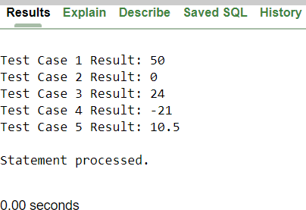

**CONCLUSION:**

* + - From this practical I’ve learnt that how can I use SQL in a way that taking two inputs whether they are integers, float ,decimal,… ; with the multiplication I can return that value also I learnt how to handle the exception in SQL.